CPSC 240: Computer Organization and Assembly Language

Final Project, Spring Semester 2024

CWID:_________________ Name:________________________

* Use YASM/NASM in Linux system for assembly language programming.
* Design a one-digit integer calculator. The program reads a constant equation from keyboard input, calculates the result, and display the equation and result to the Terminal Window.
* Operations shall include at least one addition, one subtraction, one multiplication, and one division, but they can be entered in a different order. For example, a+b*c/d-e or a*b-c+d/e, where a, b, c, d, and e are integers from 0 to 9 entered on the keyboard. The more operations a program provides, the higher the program's score. Note: 1This operation is performed from left to right, without the need for multiplication and division followed by addition and subtraction. 2Whenever possible, enter equations that evaluate to positive integers, since the display of negative integers was not discussed this term.
* Prepare a detailed report of one-digit integer calculator according to the report document and save the report in pdf format. The more detailed the documentation, the higher the documentation score.
* The grading of the final project will be broken even by two parts, 50% of the program and 50% of the report.
* Submit the document (.pdf file) and source code (.asm file) to Canvas before the deadline.
* Due: 23:59PM, Thursday (December 12, 2024), in Canvas only.
* Late final project will not be accepted.

Simulation Samples:

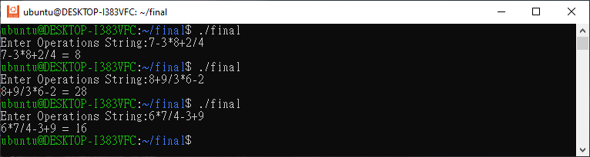

Report Documentation:

1. Cover page
   1. School name
   2. Department name
   3. Project name
   4. Student name and CWID
   5. Document date
2. Introduction
   1. Introduce the difference between keyboard input (ASCII code) and decimal number.
   2. Introduce the difference between decimal number and monitor output (ASCII code).
   3. Introduce the addition, subtraction, multiplication, and division in the assembly language.
3. Design Principle (Algorithm)
   1. Provide a flow chart and entire assembly program with comments.
   2. Provide the conversion principle (algorithm) of keyboard input to decimal numbers and symbols.
   3. Provide the conversion principle (algorithm) of decimal number to ASCII code.
4. Simulation Results
   1. Run at least three simulations and take snapshots of the Terminal Emulator. Append these pictures to the simulation results of the document.
   2. Verify the simulation results and interpret the results.
5. Conclusion
   1. Write a conclusion.

Final project grading is distinct from assignments, quizzes, and final exams. For quizzes and exams, you will receive full marks if students answer correctly. For homework, even if the student's program has a big mistake, I will only deduct a little point. However, the grading of the final project should be compared with other students in our class. The best report gets 100 points, while other students' reports get only a percentage of the best report based on the comparison with the best report. However, it is usually higher than or equal to 70 points. If the submitted report differs too much from the requirements of the final project, the report may get below 70 points.

Flow Chart

‘+’

‘-’

‘*’

‘/’

no

yes

output result

Stop

count = 4

add

sub

div

mul

op = ?

Input const. equation

Start